

TAPS Plan for Focused Assessment of Science

Topic: Sound | Year 4  Age 8-9 | Title: Investigating Pitch
  Working Scientifically  Plan: Ask relevant questions and use different types of scientific enquiries to answer them |  | Concept Context  Find patterns between the pitch of a sound and features of the object that produced it
Assessment Focus
- Can children suggest how to alter the pitch?
- Can children carry out simple tests of these ideas?
Activity Today we are acoustic scientists.

Show children some homemade ‘musical instruments’: elastic bands over shoe box, ‘straw flute/pan pipes’, ‘sound sandwich’ (lolly stick and straw harmonica), stretched balloon ‘drum skin’ over tube, glass bottle containing water to blow or tap. Explore how to play them to make a sound and ask the children to suggest which parts are vibrating. Ask children to record a range of questions that they could investigate, focusing on changing pitch (e.g. How does the width of the elastic band affect pitch?) Children then work in small groups investigating their questions, considering different ways to alter pitch.

Adapting the activity
Support: Provide question stems/scaffolded question cards, e.g. How does the ----------affect the ------etc.
Extension: Experiment with different instruments.
Other ideas: Oscilloscope (borrow from local Secondary School / You Tube videos).

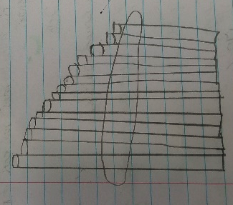
Questions to support discussion
- What are the differences between these sounds?
- Which sound is the highest/lowest?
- How could we alter the pitch?
- Does your question include what you want to change and what you are going to notice?
- How will you investigate your question?
Assessment Indicators
Not yet met: Can ask questions, e.g. which makes the highest sound? Makes some suggestions about what to do, but needs help in phrasing the question.

Meeting: Can ask questions and turn them into a form that can be investigated. E.g. How does the size of the drum affect the pitch?

Possible ways of going further: Can use their results to make a prediction to set up further comparative fair tests, e.g. I know that a small drum makes a high pitch so will a small recorder make a higher pitch than a long one?
Teacher box 3 - use Q, discussion and observation. See TAPS pyramid for more egs.

